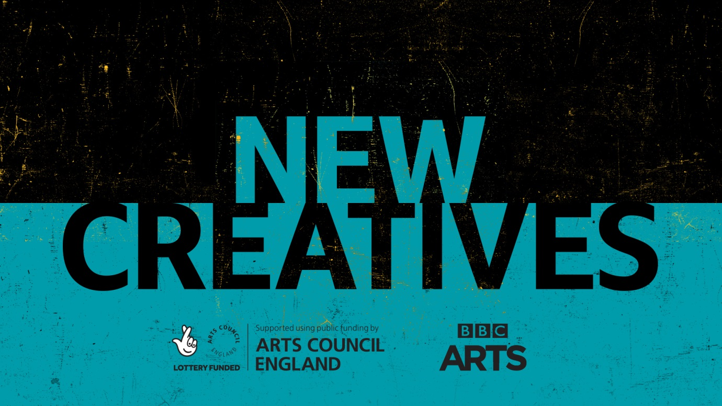

Core characteristics we’ll be looking for in our commissions:
• Relevance: the ideas and themes that really matter to you and your community – however you might define it.
• Talkability: shareable content that gets people talking
• Timeliness: things that impact people’s lives here and now
• Originality: Content that innovates
For our interactive commissions, We’re interested in supporting interesting concepts and ideas for immersive audio and video works that connect with audiences and can give an insight into a powerful experience, situation or location. These may be 360 online videos, interactive film, digital VR/AR, venue-based VR and AR or binaural experiences. We encourage experimental and innovative approaches to exploring new technologies. We encourage projects that have an online presence but projects may also be location/venue based.
Interactive and Immersive projects can range from 3 minutes up to 15mins and we encourage exploring the format during this time range.
Successful commissions will receive support from the BBC Connect team and be teamed up with a delivery partner to support the production of the work.
Depending on the scope of each project budgets will range from 10k up to 20k.

